**Assignment-2**

1. Create document objects add primary and secondary content

1.1. Checking the document object, change the primary content and checkout the document object.

1.2 Create parent child relation in documents.

2. Create Part object

2.1. Create BOM structure, Parent Child relation in parts.

**1. Create document objects add primary and secondary content**

Step1: Goto products->Folders->navigate to the “New Document" (icon) and Fill in the required metadata fields (upload primary content)->Next

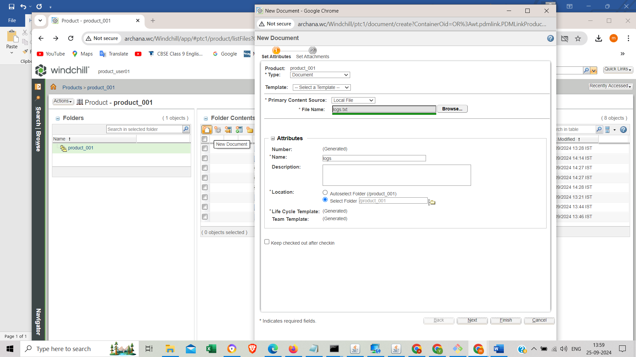

Step2: For secondary content, you can attach additional files in the "Attachments" section->Attach new local file ->Finish.

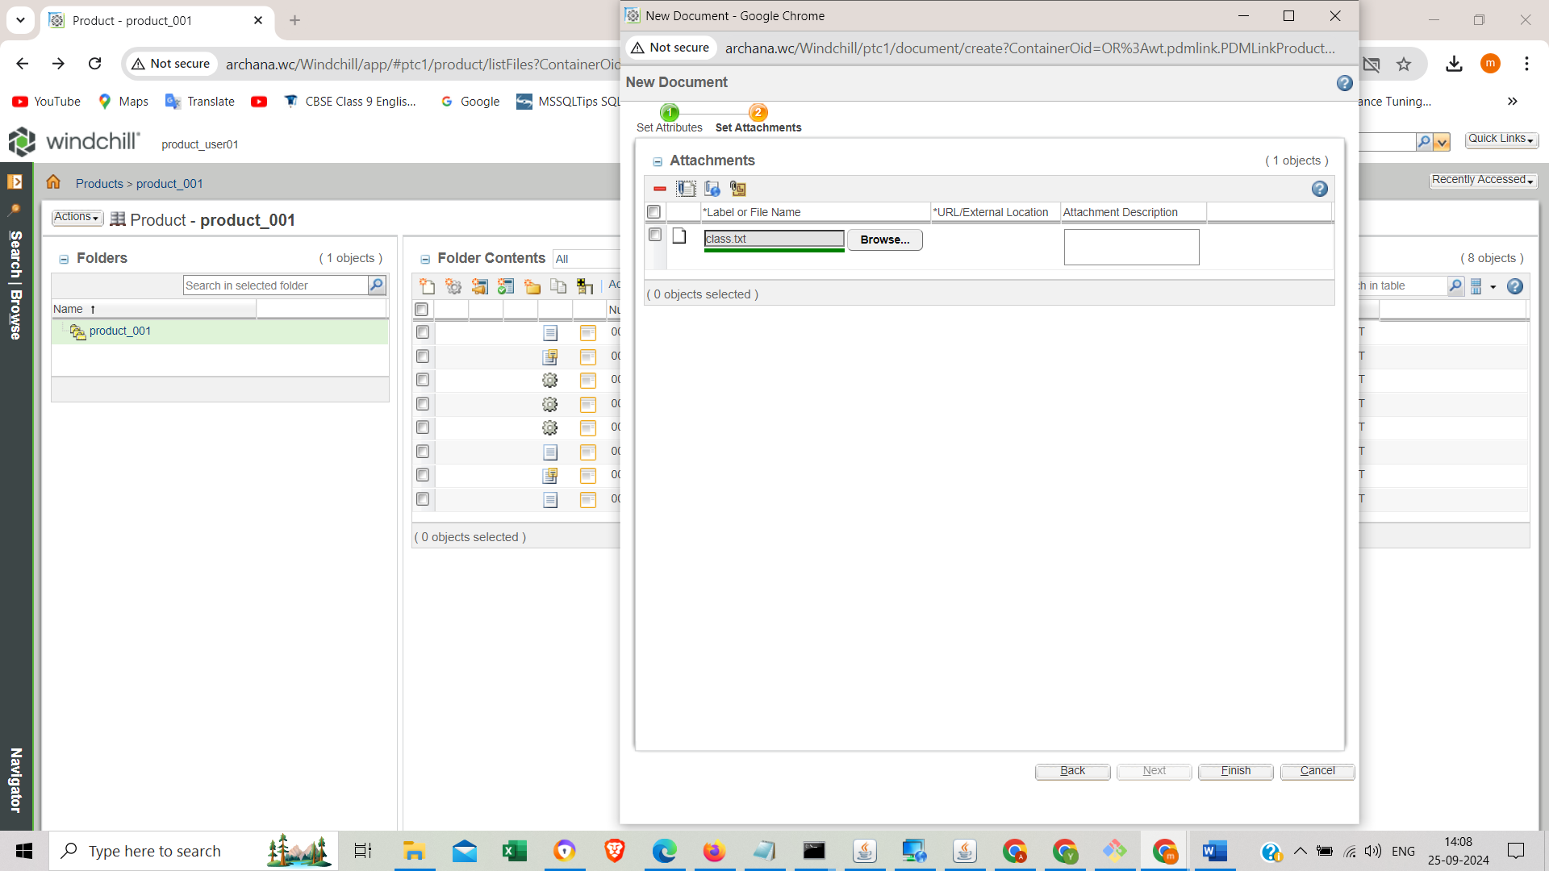

* 1. **Checking the document object, change the primary content and checkout the document object.**

Step1: select the document ->Actions -> choose checkout

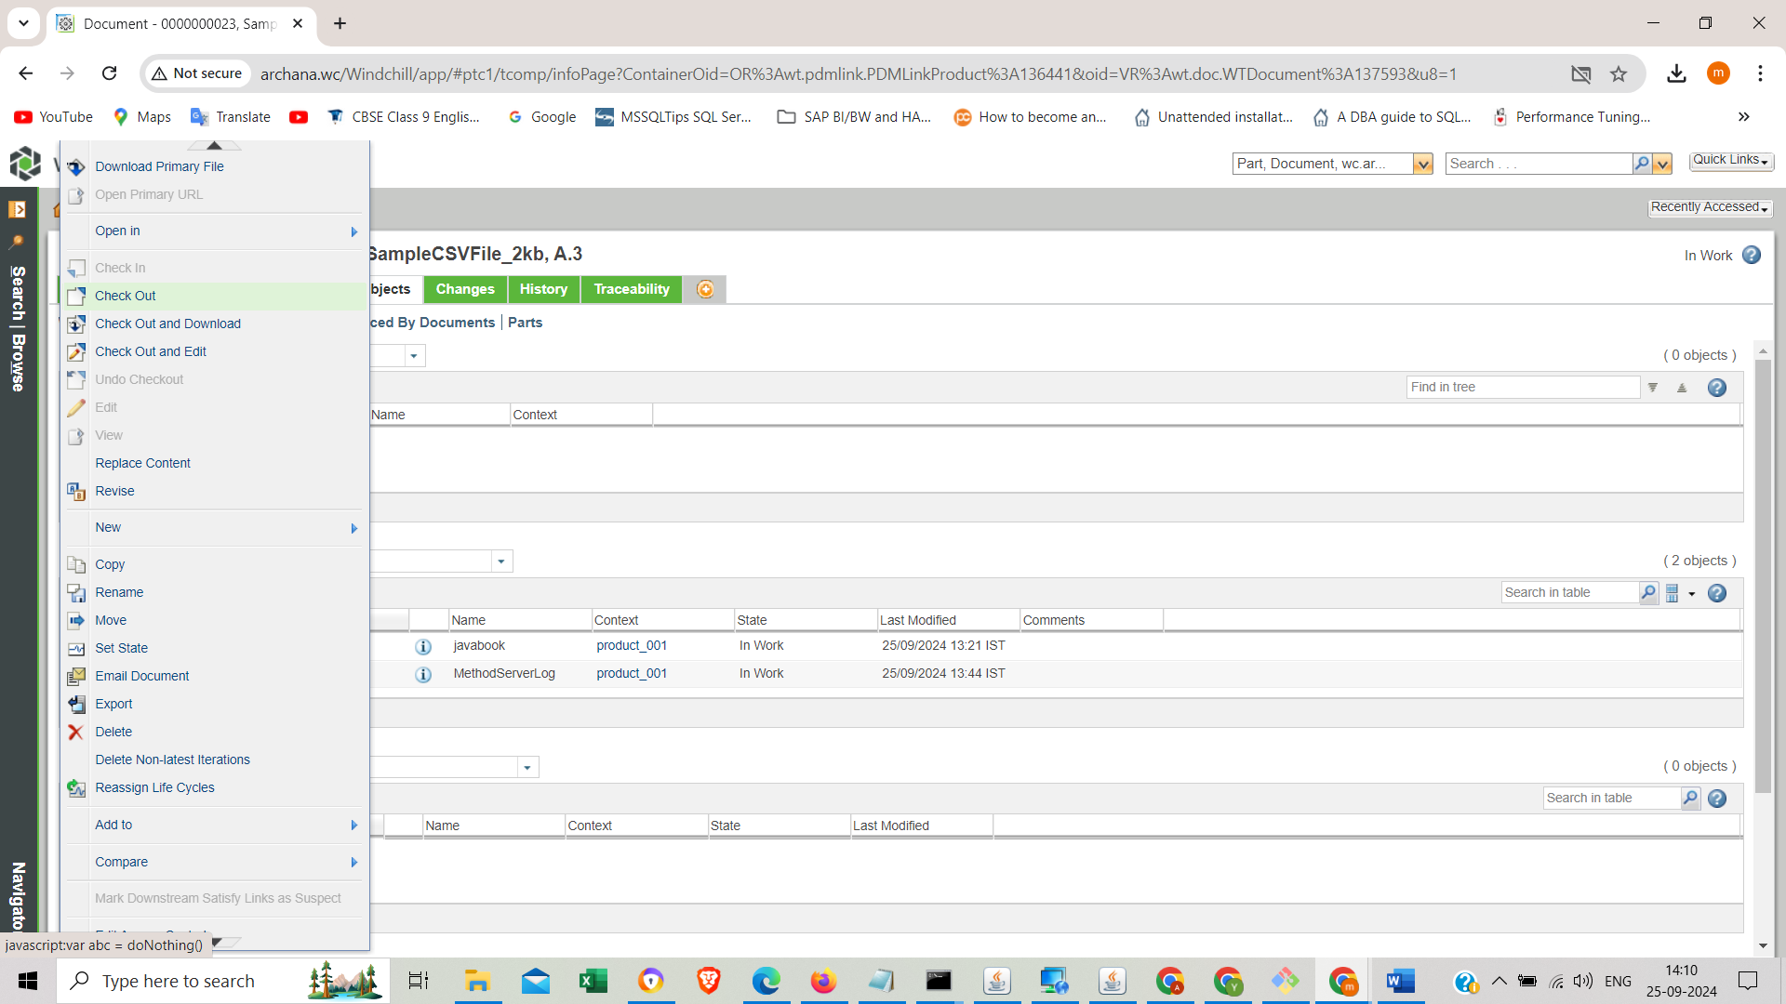

Step2: after checkout the object-> download the file into our local -> do edit and save downloaded file in to local (or even we can upload any relevant document while chek-in).

Step3: select and right click on the primary document choose ‘check-in ‘ -> browse edited file from our local-> OK.

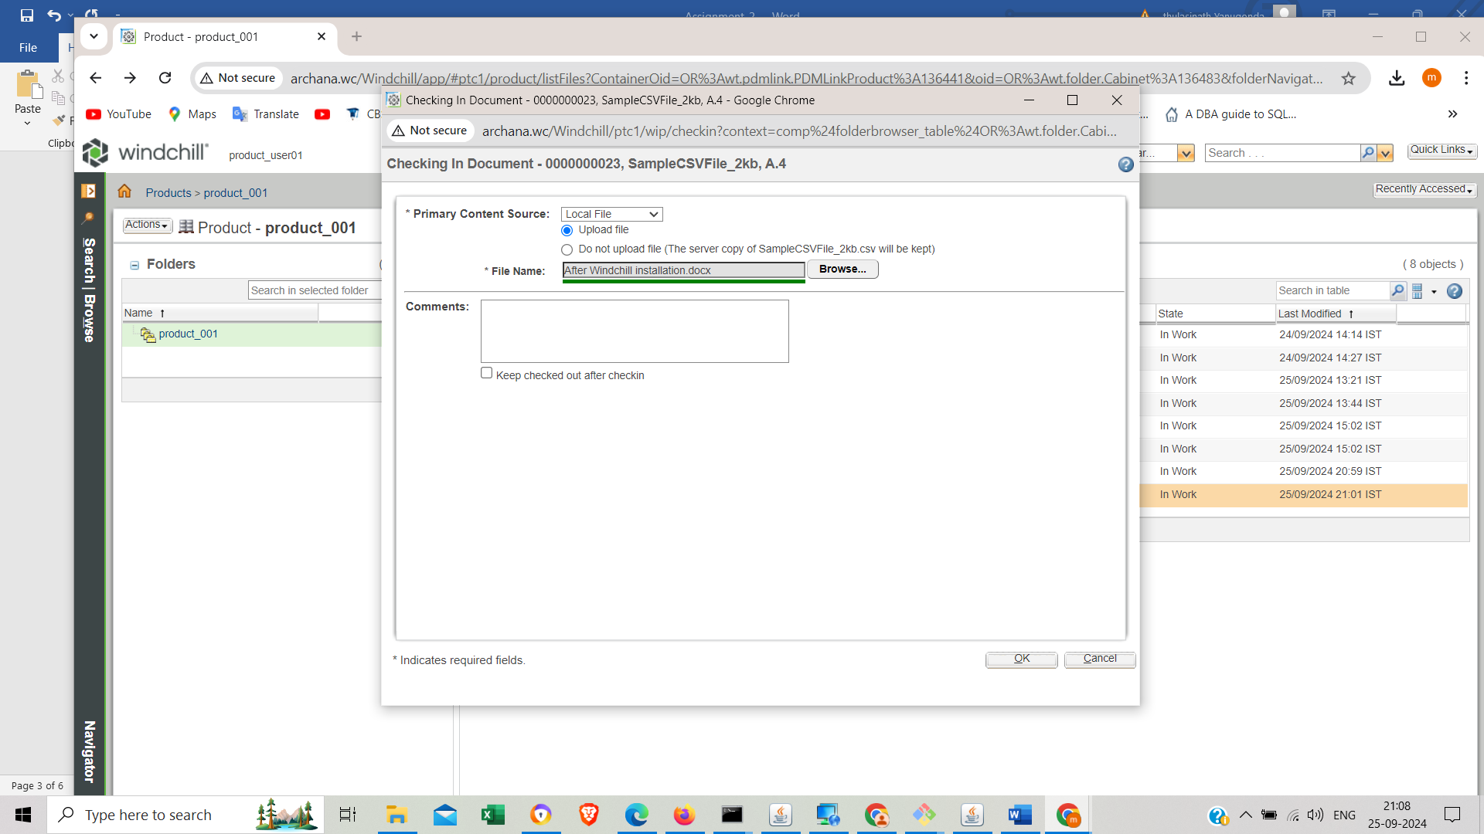

**1.2 Create parent child relation in documents.**

Step1: Open the parent document look for a ‘Structure ‘tab. right click on parent document and select insert and choose existing or new document.

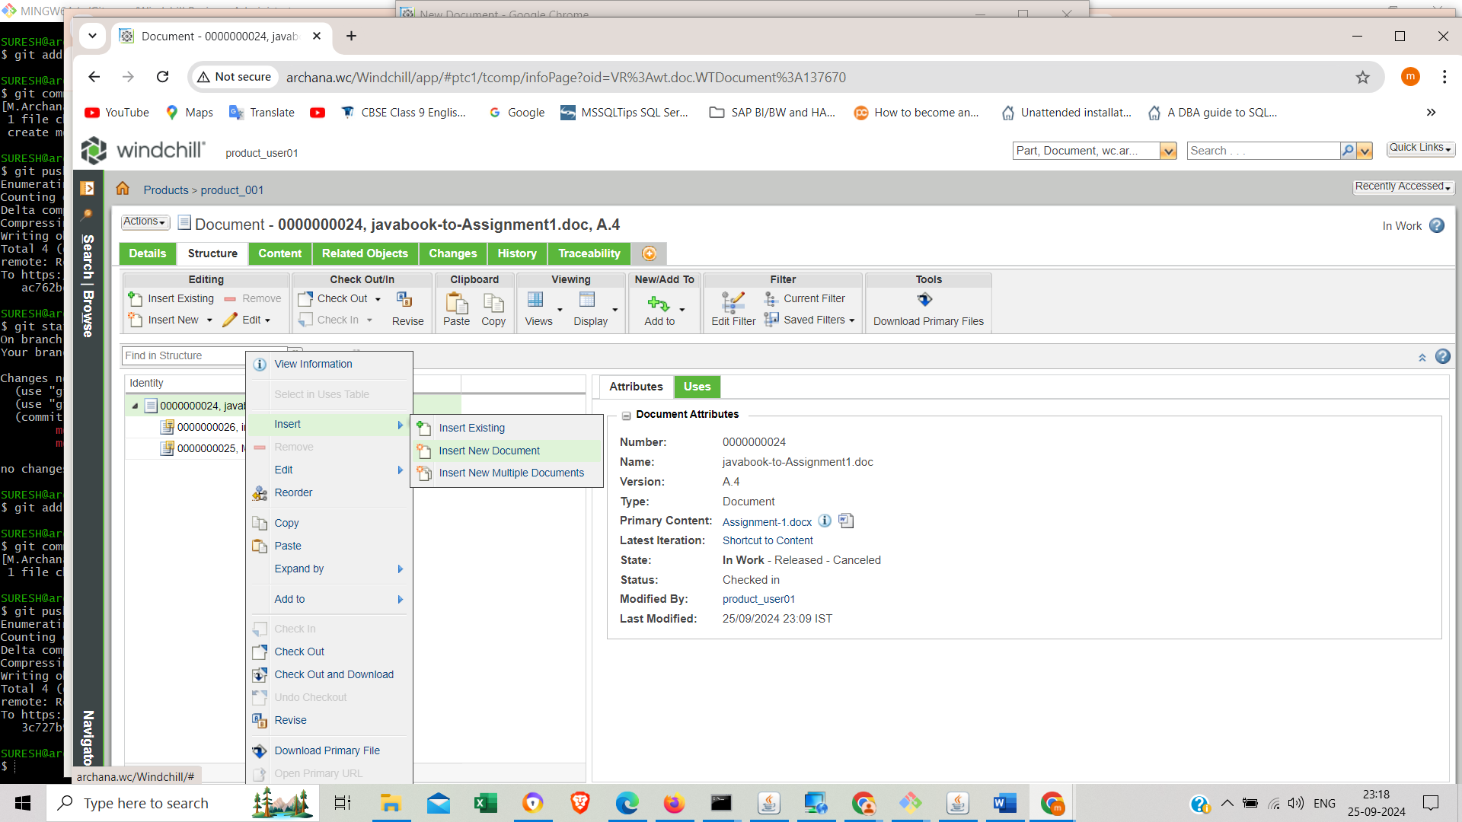

Step2: choose ‘Document’ in dropdown list -> browse a document from local ->fill required fields ->Finish

. 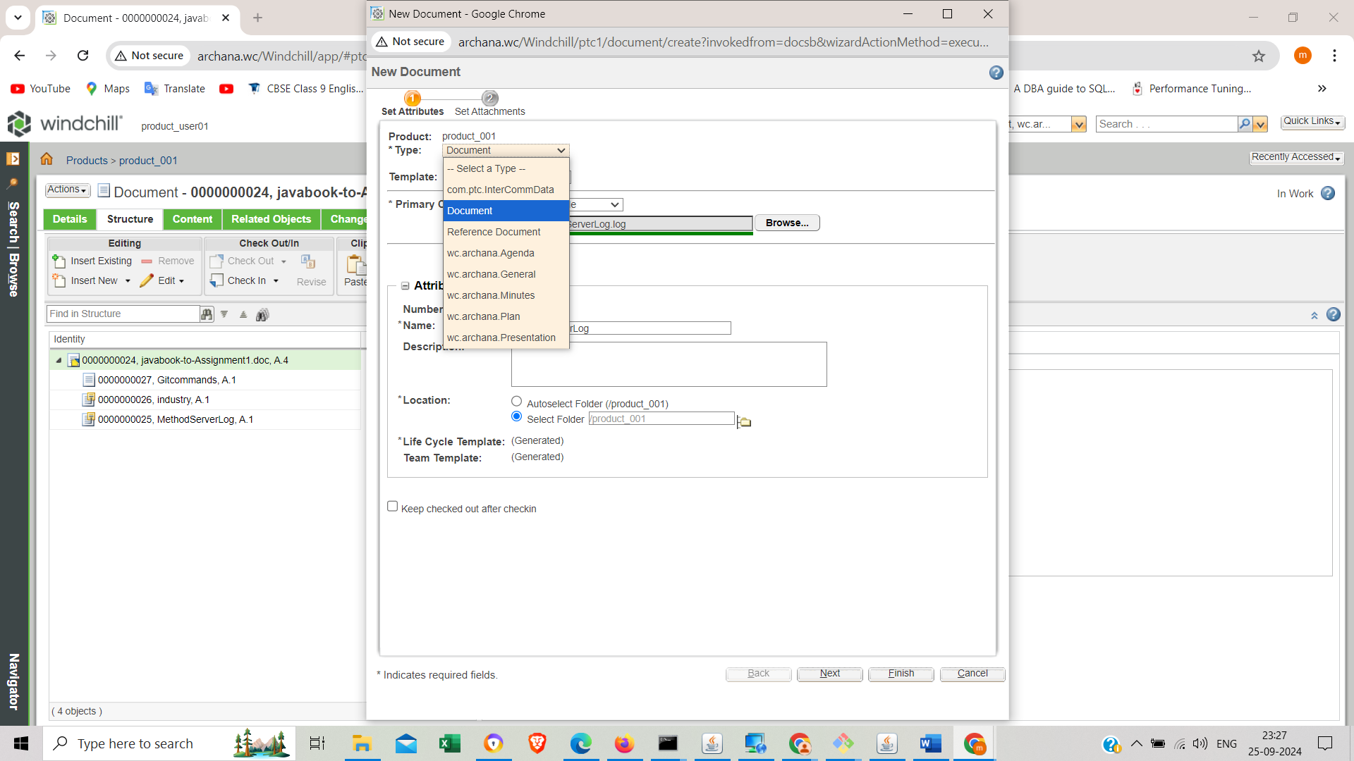

1. **Create Part object**

Step1: Go to the ‘Parts’ tab click on New Part and fill in the required fields -> choose Part in dropdown list->Finish

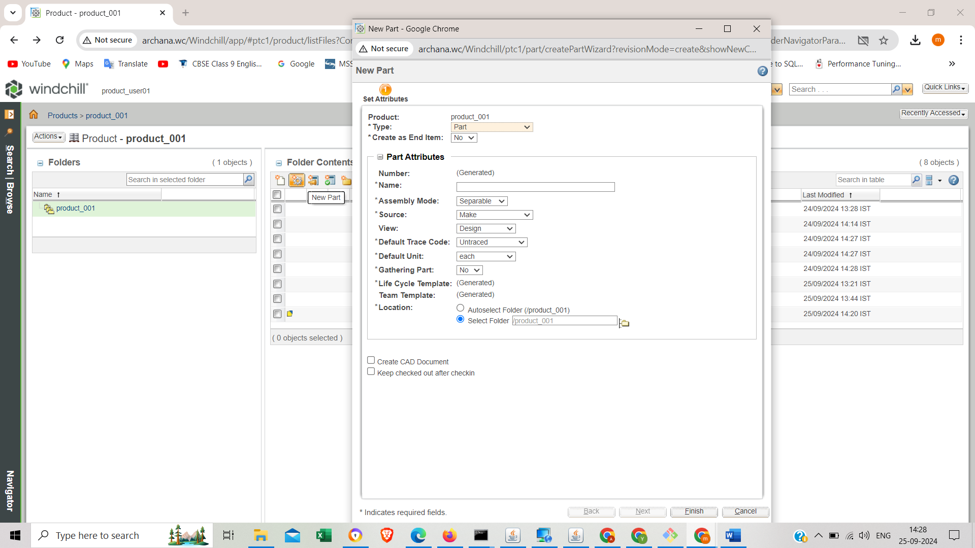

2.1.**Create BOM structure, Parent Child relation in parts.**

Step1: Open the parent Part looks for a ‘Related Objects’ section. Go to ‘Described by the document’ choose Add new document(icon).

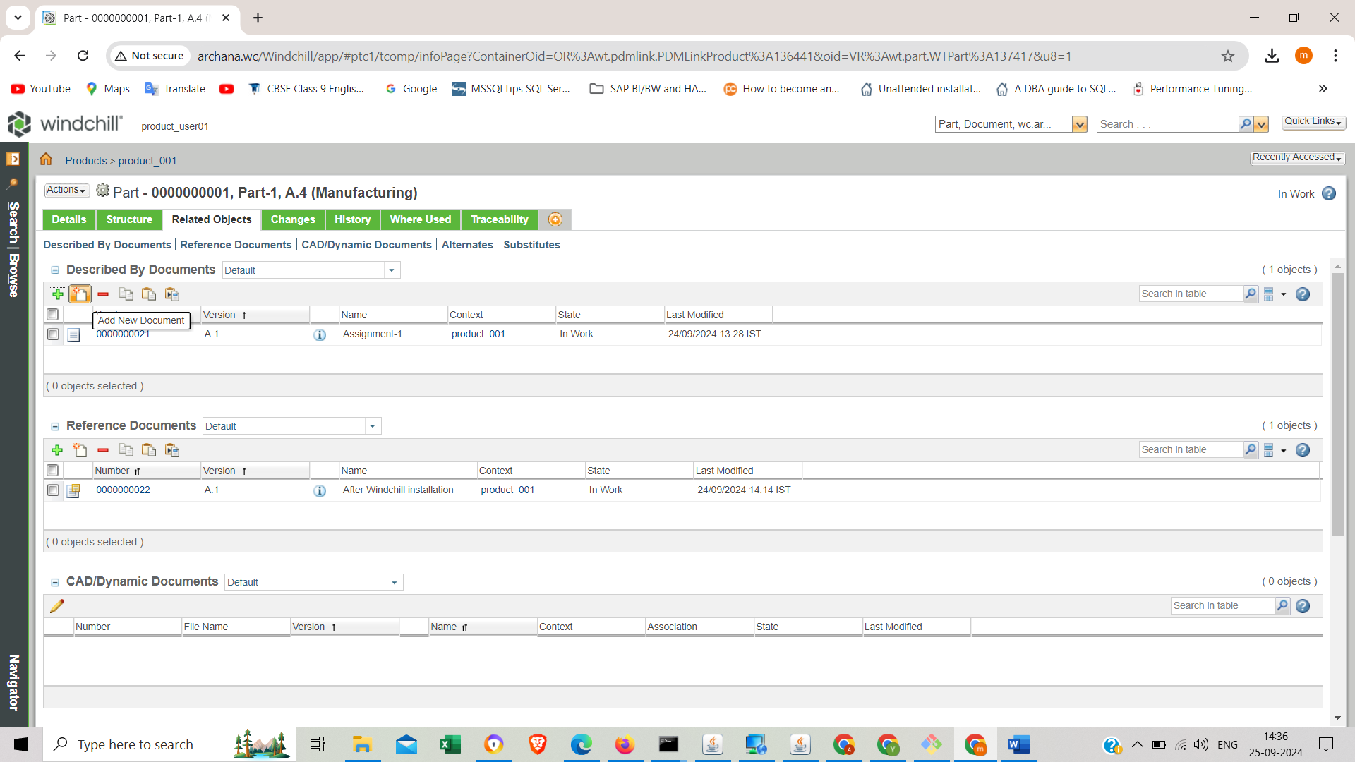

Step2: open the parent part look for a "Structure" tab Click on ‘insert New’ and fill required attributes and other BOM-specific information->finish.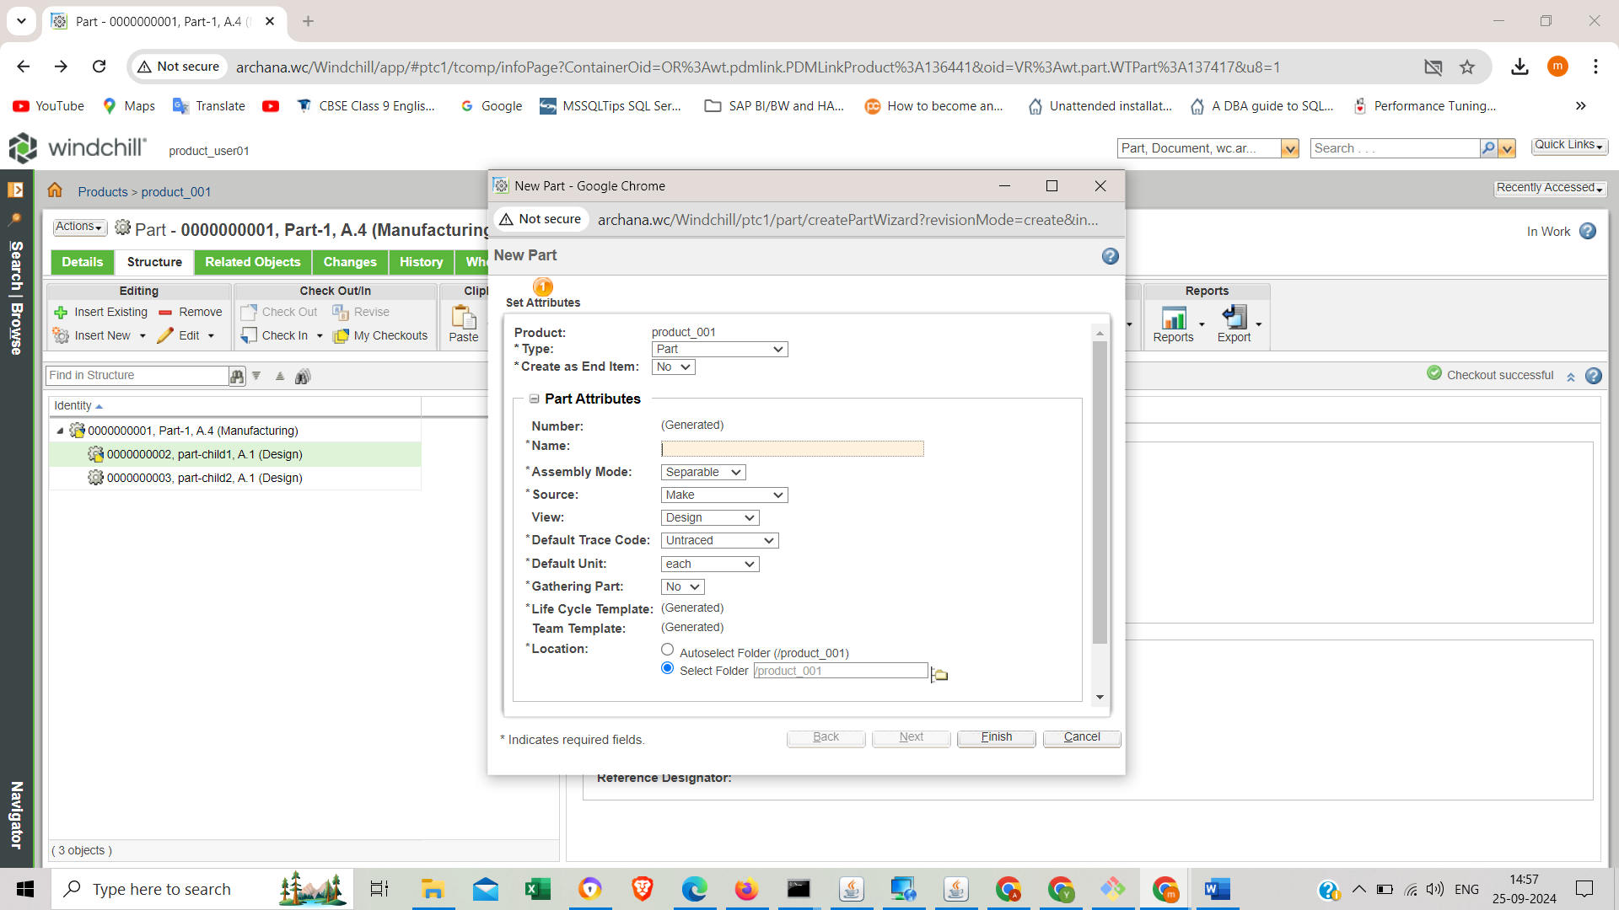

Step3: save the BOM structure(check-in)